READ ME

Dear Cermati Team,

Thank you for providing me with the opportunity to take the initial test for the STEIT position. Attached is the project I have developed based on the given assignment. In this project, I have employed a BDD Cucumber approach using the Java programming language.

To run this program, several preparatory steps are required.

1. Firstly, ensure that your laptop is using Java 11
2. Open the project using IntelliJ
3. Let Maven to download all necessary dependencies.
4. Setting JUnit
   1. Click Run -> edit configuration at IntelliJ nav bar
   2. Click + icon at upper left Run/Debug Configuration
   3. Click Junit
   4. Click add class

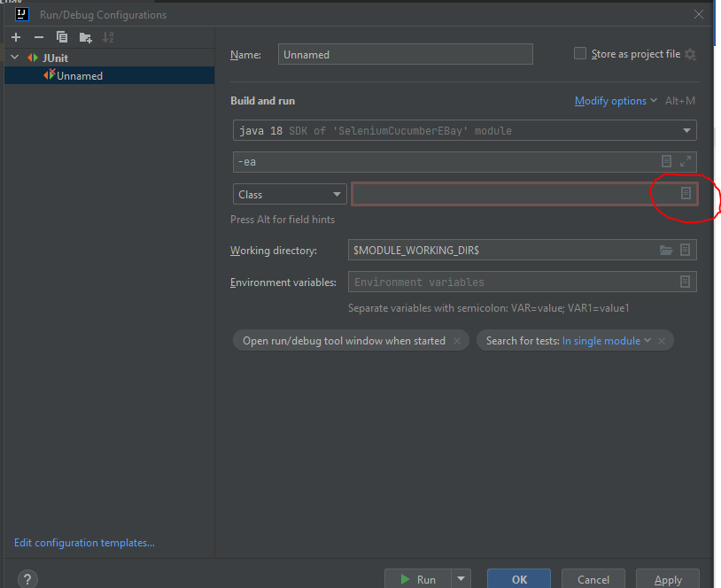

* 1. Choose Test Runner

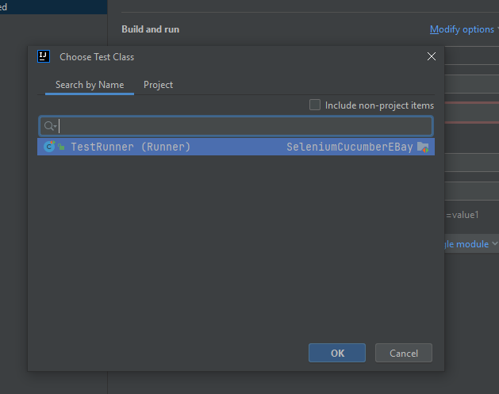

* 1. You fill any name in Name section -> click ok
  2. Now you ready to run the automation
  3. To run the automation, you can just click play icon on upper right
  4. AccessProduct.feature
  + This project contains only two scenarios. By default, both scenarios will run when you start the automation. However, you can choose to execute specific scenarios by using their tags

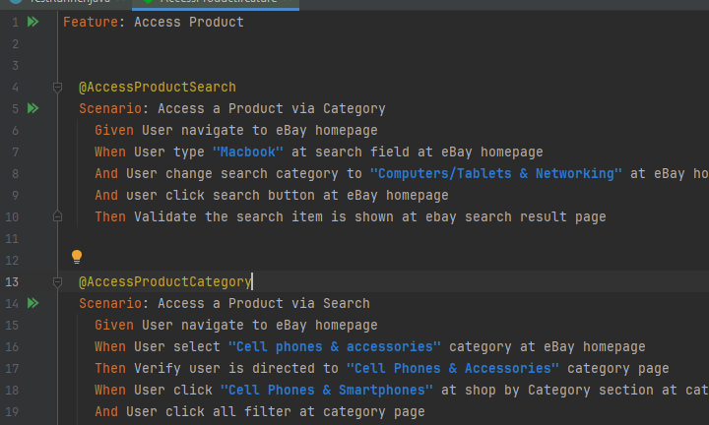

* 1. TestRunner.java
  + You can select which scenarios to run by copying their tags into a designated section. If no tags are specified, both scenarios will execute by default

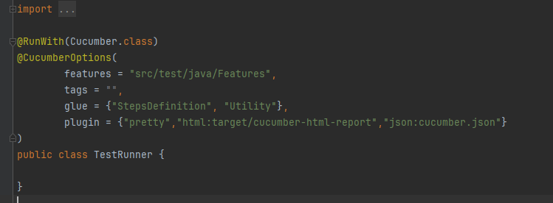

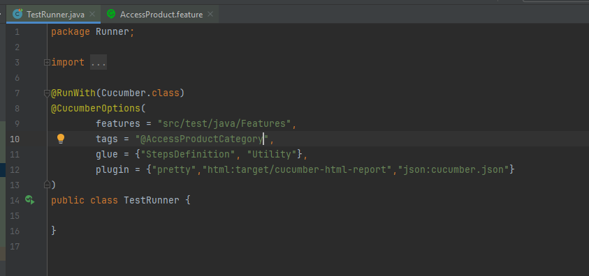

* 1. You can select the desired browser for testing. This project supports Chrome (chrome), Firefox (firefox), and Safari(safari). Just change the browser here

